Technical documentation - Testing

Website word counter

Jack Oporto

October 24, 2020

Professor Al Kafaf

**Summary:**

This documentation explains the test cases created for the website word counter program.

**Implementation:**

Even after watching a handful of videos I’ve really struggled to create good tests for my program. The tests I’ve implemented are basically copies from the tutorial videos.

Key issue: I don’t understand how to test methods that aren’t primitive data types.

For example: It’s easy to give an expected value for an int, Boolean or even string, but something like a hashmap I don’t understand how to give it that expected value.

My scrapeData() function is supposed to return the entire poem, scraped from the website so the only solution that seemed to work was to put the entire poem into a string and place it as the expected value returned.

**Functions:**

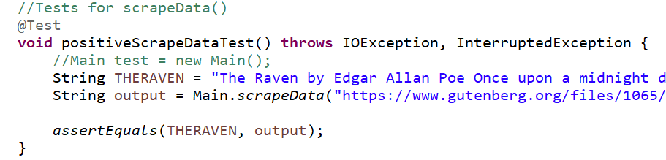

My scrapeData() function is supposed to return the entire poem, scraped from the website so the only solution that seemed to work was to put the entire poem into a string and place it as the expected value returned.

This test works, and returns successful.

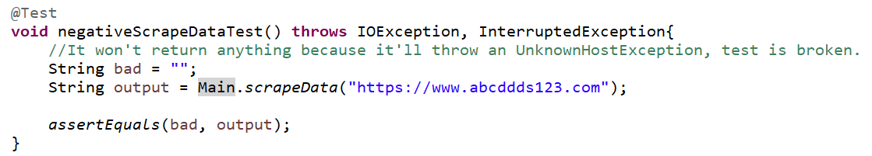

This test is broken because it’s expected to return an UnknownHostException, not a value, don’t know enough about tests at this point to create working tests for non-primitive methods.

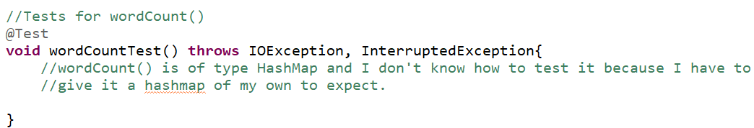

This is the same expectation for every other method in the program.